Experiment 21:
Aim:
21.Write a Pandas program to swap the cases of a specified character column in a given DataFrame.
Python code:
import pandas as pd

# Create DataFrame
data = {
"name_code": ["c001", "c002", "c003", "c004"],
"name": ["Alberto Franco", "Gino Mcneill", "Ryan Parkes", "Eesha Hinton"]
}
df = pd.DataFrame(data)
print("Original DataFrame:")
print(df)

# Swap the case of the 'name' column
df["name"] = df["name"].str.swapcase()
print("\nDataFrame after swapping the case of 'name' column:")
print(df)
Output:
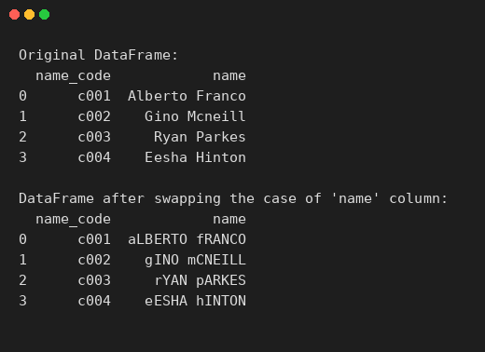
Experiment 22:
Aim:
22.Write a Python program to draw a line with suitable label in the x axis, y axis and a title.
Python code:
import matplotlib.pyplot as plt

# Data for the line
x = [1, 2, 3, 4, 5, 6, 7]
y = [2, 4, 5, 7, 6, 8, 9]

# Draw the line
plt.plot(x, y, marker='o', color='b', label='Sample Line')

# Add labels and title
plt.xlabel('X-axis Label')
plt.ylabel('Y-axis Label')
plt.title('Line Plot with Labels and Title')
plt.legend()

plt.show()
Output:
